**Part2**

1. Create a query to display the last name and salary of employees earning more than $1200.
2. 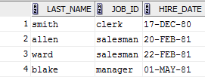Display the employee last name, job ID, and start date of employees hired between February 20, 1980, and May, 1, 1981. Order the query in ascending order by start date.
3. 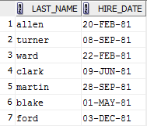Display the last name and hire date of every employee who was hired in 1981.
4. Display the last name, salary and commission for all employees who earn commissions. Sort data in descending order for salary.

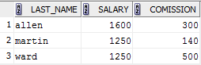

1. Display the last names of all employees where the third letter of the name is an “a”.



1. Display the last name of all employees who have an “a” and “e” in their last name.

